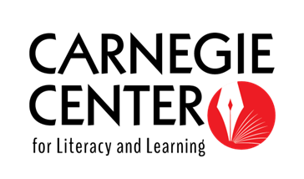
Young Writers Project 2027

The Carnegie Center invites young women, nonbinary students, and members of historically underrepresented genders in GRADES 9-12 to apply to the Young Writers Project, a FREE series of intensive workshops focused on creative self-expression through writing. The selected participants will attend seven sessions (see below). In these workshops, experienced writers in their 20s and 30s will mentor on a variety of genres, encouraging participants to look within themselves for issues that are important in their lives. Participants will also learn techniques of delivering an effective literary reading and other business-of-writing tips. The program will culminate in a public reading, a Writing Mentoring Day, and a chapbook of student work.

WHERE & WHEN: All sessions take place at the Carnegie Center for Literacy and Learning (251 West Second Street, in downtown Lexington, KY). Participants must commit to attending all seven sessions.

February 20: Workshop TBD
February 27: Workshop TBD
March 6: Workshop TBD
March 13: Workshop TBD
March 20: Workshop TBD
March 27: Workshop TBD
April 3: Workshop TBD

MENTORING DAY: Participants will attend a Writing Mentoring Day at a local elementary school (typically a weekday in April from 3-5pm; exact date/time TBD). The Carnegie Center can provide a letter to schools requesting early dismissal if needed. Participants will create and orchestrate creative writing exercises with 4th and 5th graders. Cash stipends are provided for Mentoring Day participation.

PUBLIC READINGS: Participants will be invited to showcase their writing in a public reading at the Carnegie Center (May 2027). Cash stipends are provided for participation in the reading.

COST: There is NO application or participation fee! Students admitted to the program will receive full scholarships. Participants are asked to bring bag lunches, as lunch will not be provided. The Young Writers Project is funded in part by the Kentucky Foundation for Women.

ADMISSION: To be considered for the Young Writers Project, please submit the following:
- a completed cover sheet
- a letter stating your interest and motivations for participation
- a writing sample (5 pages maximum)
- a photo/video release form (if you do not give permission for us to use your photo, please make a note on the form)

APPLICATION MENTORING: Mentors are available to you for free to assist with preparing your
application materials. All interested applicants are encouraged to schedule time with a mentor. Please reach out ahead of the application deadline.

This program welcomes participants with diverse expressions of cultural identity; from varying communities of place; and with a range of worldviews, races, ethnicities, gender identities, sexual orientations, and levels of ability.

Applications open Tuesday, September 1, 2026.

Application should be postmarked, hand-delivered to the Carnegie Center, or emailed with the subject line “Young Writers Project Application” to Maggie Garnett at maggie@carnegiecenterlex.org by FRIDAY, DECEMBER 11. Cohort will be limited to 15 young writers.

Applicants will be notified no later than February 1, 2027.

For more information, contact Maggie Garnett at maggie@carnegiecenterlex.org.

Send cover sheet, letter of interest, and writing sample to:
Young Writers Project
The Carnegie Center for Literacy and Learning
251 West Second Street
Lexington, KY 40507


Thanks to our funder:

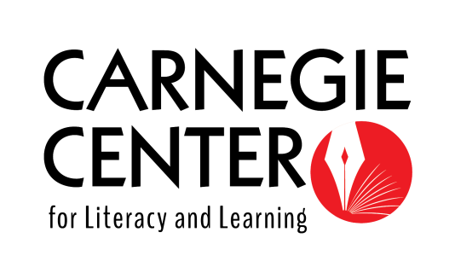
Young Writers Project 2027
Cover Sheet

Applicant Name ____________________________________________________________________________________

Guardian Name__________________________________________________________________________________

Mailing Address________________________________________________________________________________

City _______________________________ State ________Zip ____________ County____________________________

Phone Number _______________________________________________________________________________

Applicant Email Address _____________________________________________________________________________

Guardian Email Address___________________________________________________________________________

Grade ________
School_________________________________________________________________________

How did you learn about the Young Writers Project? ______________________________________________________________________________________

________________________________________________________________________________________

________________________________________________________________________________________

If selected to participate in the Young Writers Project, I commit to attending all seven sessions and the Writing Mentoring Day. I will also attend the public reading if at all possible. I understand that this program welcomes participants with diverse expressions of cultural identity; from varying communities of place; and with a range of worldviews, races, ethnicities, gender identities, sexual orientations, and levels of ability.

Student Signature __________________________________________ Date ______________________

Parent/Guardian Signature _____________________________________ Date ______________________

Applicants will be notified no later than February 1.
Young Writers Project 2027

Photograph & Video Release Form

I hereby grant permission to the rights of my image, likeness and sound of my voice as recorded on audio or video tape without payment or any other consideration. I understand that my image may be edited, copied, exhibited, published, or distributed and waive the right to inspect or approve the finished product wherein my likeness appears. Additionally, I waive any right to royalties or other compensation arising or related to the use of my image or recording. I also understand that this material may be used in diverse educational settings within an unrestricted geographic area.

Photographic, audio or video recordings may be used for the following purposes:
- conference presentations
- educational presentations or courses
- informational presentations
- online educational courses
- educational videos
- media coverage
- program publicity
- grant reports

By signing this release, I understand this permission signifies that photographic or video recordings of me may be electronically displayed via the Internet or in the public educational setting.

I will be consulted about the use of the photographs or video recording for any purpose other than those listed above.

There is no time limit on the validity of this release nor is there any geographic limitation on where these materials may be distributed.

By signing this form, I acknowledge that I have completely read and fully understand the above release and agree to be bound thereby. I hereby release any and all claims against any person or organization utilizing this material for educational purposes.

Applicant Name ________________________________________________________________

Signature____________________________________________________________ Date______________________

(If under 18) Parent’s Signature_______________________________________ Date______________________

